Darkly (pvictor)

# Hack 1: MD5 cookies

Change the value of the cookies i_am_admin to b326b5062b2f0e69046810717534cb09 (aka true in md5, instead of false as previsous value)

**df2eb4ba34ed059a1e3e89ff4dfc13445f104a1a52295214def1c4fb1693a5c3**

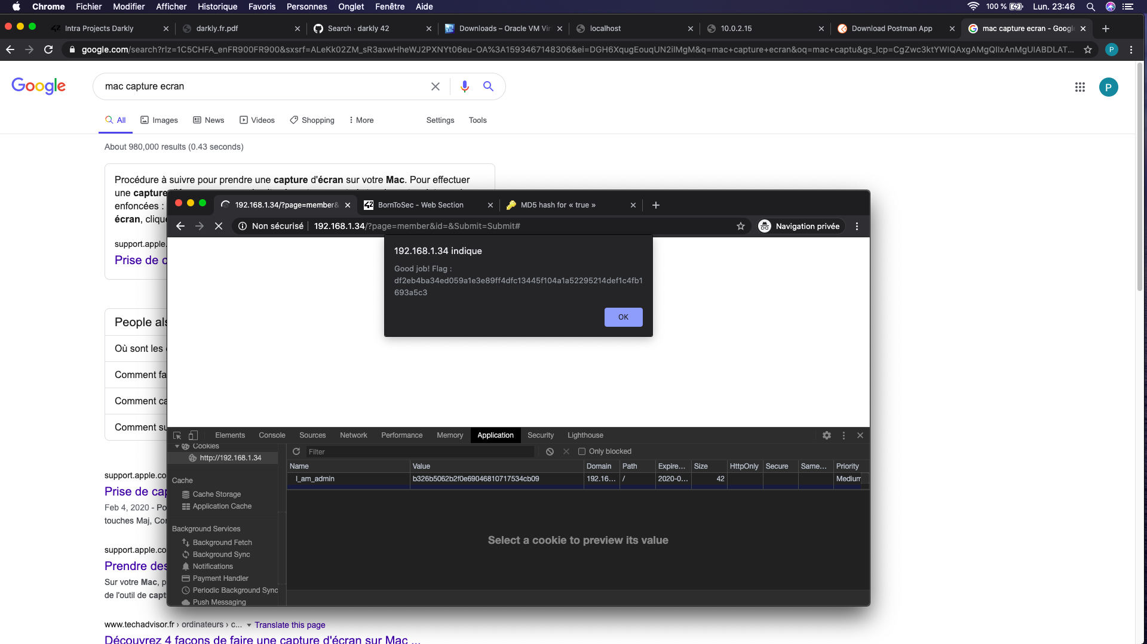

# Hack 2: Option tempering

Change the value of the option in the survey to some random number (it has to be numbers, no strings) and submit the corresponding option.

* The data from the users should be tested.

THE FLAG IS 03A944B434D5BAFF05F46C4BEDE5792551A2595574BCAFC9A6E25F67C382CCAA

# Hack 3: Robots.txt

About Robot.txt : <https://support.google.com/webmasters/answer/6062596?hl=en>

Robots.txt gives rules to google bots about which files

1. Go to <ip>/robots.txt

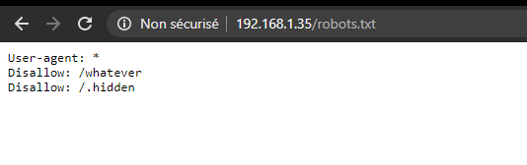

1. Go to /whatever

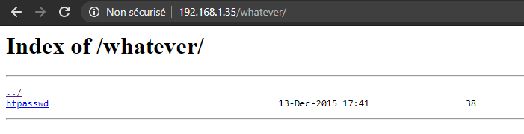

1. Download htpasswd

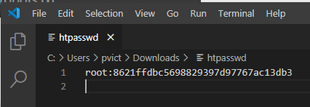

1. Put the password on google: it’s md5 for “dragon”
2. Go to <ip>/admin and connect with root / dragon

THE FLAG IS d19b4823e0d5600ceed56d5e896ef328d7a2b9e7ac7e80f4fcdb9b10bcb3e7ff

# Hack 4: Reset password

1. Go to recover password: <ip>/index.php?page=recover#
2. Inspect the submit button

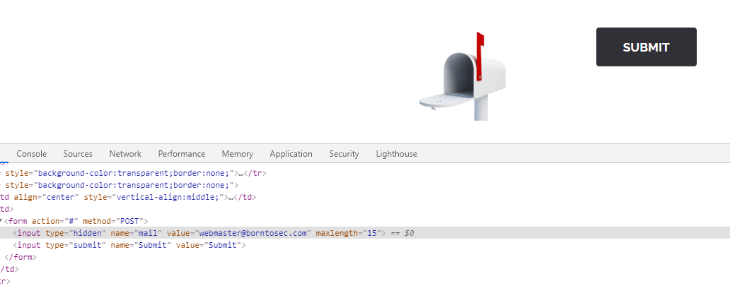

1. Change the value of the email

THE FLAG IS 1D4855F7337C0C14B6F44946872C4EB33853F40B2D54393FBE94F49F1E19BBB0

# Hack 5: JS Injection

Go to the feedback section, and enter “script” in the comment section

THE FLAG IS : 0FBB54BBF7D099713CA4BE297E1BC7DA0173D8B3C21C1811B916A3A86652724E

# Hack 6: Changing the value of a link

1. Go to the main page
2. Scroll down to the social network links
3. Inspect one and change its href (param “site”)

The flag is : B9E775A0291FED784A2D9680FCFAD7EDD6B8CDF87648DA647AAF4BBA288BCAB3

# Hack 7: SQL injection

1. Go to the search image page
2. In the input field, put “1 or 1=1 UNION select table_name, column_name FROM information_schema.columns” in order to get information about the tables from the db
3. We get the following information about the list_images table

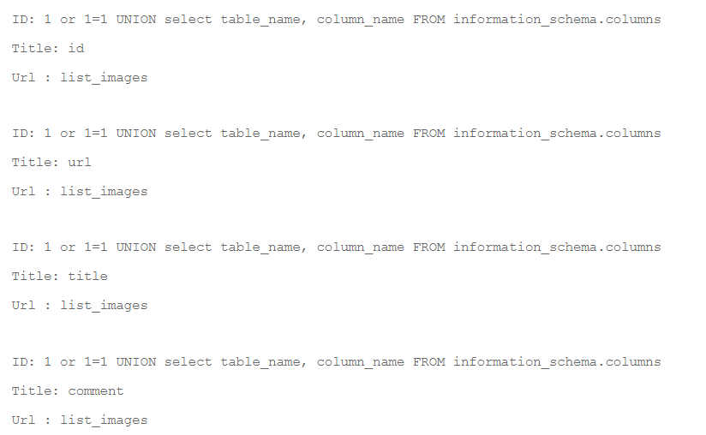

1. We put “1 or 1=1 UNION select url, comment from list_images”



1. We obey: use Google to decode (🡺 “albatroz”), then sha256

The flag is : f2a29020ef3132e01dd61df97fd33ec8d7fcd1388cc9601e7db691d17d4d6188

# Hack XX: image

var test = "<script>alert('42');</script>"

btoa(test); 🡺 "PHNjcmlwdD5hbGVydCgnNDInKTs8L3NjcmlwdD4="

# Hack XX – password brut force

nmap

<https://null-byte.wonderhowto.com/how-to/brute-force-ssh-ftp-vnc-more-with-brutedum-0197449/>

Try Vega ?

# Hack XX: SQL Injections

Write "<script>alert("loser");</script> in Search Members

We know that the field is not protected against SQL Injections

# Key takeways from the project

* No hash values in cookies (use jwt instead)